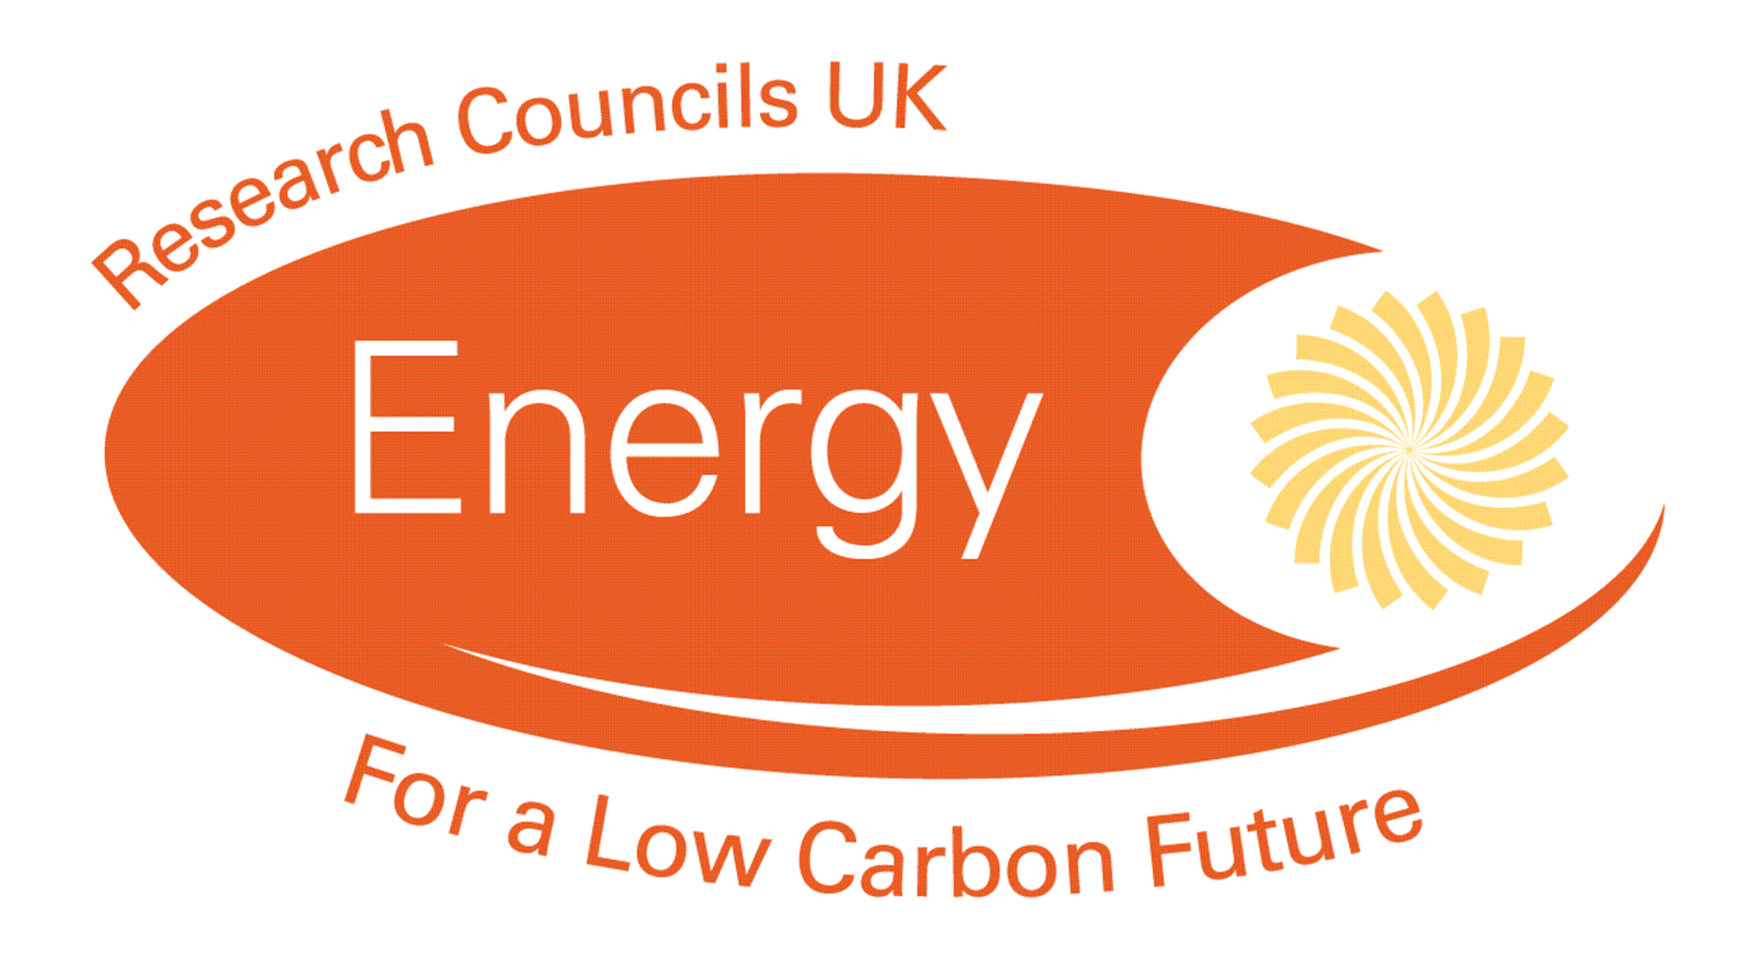

INTERNATIONAL AND INDUSTRIAL ENGAGEMENT FUND Call

The EPSRC SUPERGEN SuperSolar Network+ wishes to grow the PV research network and create solid partnerships with UK industry to assist commercialisation of research. This can be achieved in a number of ways including direct secondments or exchanges. The SuperSolar Network+ also wishes to encourage engagement with international research partners. This should accelerate research, access know-how and facilities, and learn from best practice developed by leading overseas laboratories.

All projects must be completed and invoices submitted by 1st October 2019.

The following types of activities are examples of eligible projects:

UK Industry

- Industry led problems addressed by a company/university partnership. Activities can include exchange of personnel, e.g. academic researcher to company site and/or industrial researcher to an academic site.
- Market analysis and/or business case development in collaboration with an industrial partner.
- Proof of concept / prototyping work in collaboration with an industrial partner

International

- Placement of a UK researcher at a leading international laboratory.
- Placement of an international researcher in a UK university.
- Funding to support international network development activities e.g. support to enable large scale, collaborative bids to be developed with international partners.
- Fostering international industrial support - support to build new, and strengthen existing industrial engagement with overseas companies.

All SuperSolar network and associate members are invited to submit proposals. In line with the notes on finance below, the grants will be awarded at 100% Full Economic Cost (FEC), although the participating universities will receive 80% FEC, in line with normal EPSRC funding arrangements. In all cases, the Grants Committee will be assessing value for money.

The submitted proposals should be a maximum of 2 pages using the template provided to include:

- If the application is to the industrial or the international fund.
- A brief description of the proposal including the aims and objectives (case for support)
- If a secondment is proposed: A brief resume of the person to be seconded
- A justification of resources
- A cost analysis using the template supplied

In addition to the proposal, a short (no longer than 1/2 page) summary of the relevant expertise and/or facilities of the research team making the proposal is optional.

The deadline for proposals is 12 noon on 14 November 2018. Proposals should be sent electronically to S.A.Henson@lboro.ac.uk. Any questions relating to the application procedure should be addressed to: Sharon Henson, (Supersolar Network+ co-ordinator), contact details below.

The Network+ Director will make a recommendation to the Grants Committee on which proposals to fund. The proposals identified as suitable for funding will be then subject to additional scrutiny by members of the Strategic Advisory Panel. Final decisions will be made available to applicants in December 2018.

A purchase order will be issued to successful applicants. The recipient must submit an invoice based on actual expenditure before 1st October 2019. Payments will be made after the secondment has taken place and a report has been submitted. Larger sums will require a contract with Loughborough University. All grant recipients must provide a short report (no more than 1000 words) identifying the impacts of the secondment on completion.

Notes on finance

Companies are not eligible to make applications. However, applications can be made through the collaborating University.

Company staff costs are not eligible unless the individual is seconded into the University. Universities can apply for consumable costs where appropriate.

All DI costs can be paid, but not overheads.

Generally, staff costs will not be covered for short trips (less than 3 months).

Any other variations will be reviewed on a case by case basis by the Network+ Director and the SuperSolar Grants Committee.

Applications in excess of £20k are unlikely to be successful.

Sharon Henson, EPSRC SUPERGEN SuperSolar Co-ordinator, CREST, School of Electronic, Electrical and Systems Engineering, Loughborough University, Garendon Wing, Holywell Park, Loughborough, LE11 3TU. Tel: 01509 227128 Email: s.a.henson@lboro.ac.uk

03/10/2018

 | International Fund | Industrial Fund
Application to
PROJECT TITLE

APPLICANT (Application should be made by a PI, not the person going on the secondment)
Name

University
Address

Email
Telephone

SECONDMENT TO
Name of institution/company

Address

Main contact name
Email address
Telephone

BRIEF PLAN Please describe the timescales for your secondment including the duration.

BRIEF RESUME (of the person who will be seconded)

JUSTIFICATION OF RESOURCES

CASE FOR SUPPORT

