**Template For the 2nd Indo – UK PV Soiling workshop and Extended Abstract Preparation Guidelines (Title in 16-point Times New Roman font)\***

1st Given Name Surname, 2nd Given Name Surname, and William R. Cherry (List authors on this line using 12 point Times font – use a second line if necessary)

Institute Name, City, State/Region, Mail/Zip Code, Country (authors’ affiliation(s) listed here in 12 point Times font – use a second line if necessary)

*Abstract*—This electronic document is a “live” template and already defines the components of your paper [title, text, heads, etc.] in its style sheet. Use 12 point Times New Roman Bold font for the abstract. Indent the first line by 0.19 inches and type the word "Abstract" in 12 point Times New Roman Bold Italic. This should be followed by a long dash (option / shift / minus) and then the first word of your abstract (as shown above) without any spaces in between. Please try to keep the length of your abstract to 100 words or less. *\*CRITICAL: Do Not Use Symbols, Special Characters, Footnotes, or Math in Paper Title or Abstract*. (*Abstract*)

# Introduction (*Heading 1*)

This template, provides authors with most of the formatting specifications needed for preparing electronic versions of the final version of their papers. All standard paper components have been specified for three reasons: (1) ease of use when formatting individual papers, (2) automatic compliance to electronic requirements that facilitate the concurrent or later production of electronic products, and (3) conformity of style throughout a conference proceedings. Margins, column widths, line spacing, and type styles are built-in; examples of the type styles are provided throughout this document and are identified in italic type, within parentheses, following the example.

The template is used to format your paper and style the text. All margins, column widths, line spaces, and text fonts are prescribed; please do not alter them. You may note peculiarities. For example, the head margin in this template measures proportionately more than is customary. This measurement and others are deliberate, using specifications that anticipate your paper as one part of the entire proceedings, and not as an independent document. Please do not revise any of the current designations.

The best approach of using this template is to save it under a new name and copy and paste the manuscript data in it. **Please note: text has to be pasted as unformatted text in order not to change the formatting.** Submissions should follow the exact details of this template.

# Extended abstract

## General requirements (Heading 2)

A contributor should remember the following points:

* Extended abstract is limited to 3 pages.
* The 3-page extended abstract is the most essential part of your abstract submission, since it is the part that will be reviewed by the Program Committee. To help them with their assessment of your paper, please make sure that your extended abstract is no more than 3 pages in length, and includes these main points:
  + Introduction or background of the paper topic
  + Main experimental and/or theoretical results
  + Analysis of the results, clear exposition of the main findings
  + Summary of the work
  + References.

##### References

1. F. Author et al., IEEE J. Photo. Volt., vol. XX, No. YY, 2019.

***Insert Tables and Figures in here***

TABLE I : EXAMPLE OF TABLE CAPTION

| Table Head | Table Column Head | | |
| --- | --- | --- | --- |
| Table column subhead | Subhead | Subhead |
| copy | More table copya |  |  |

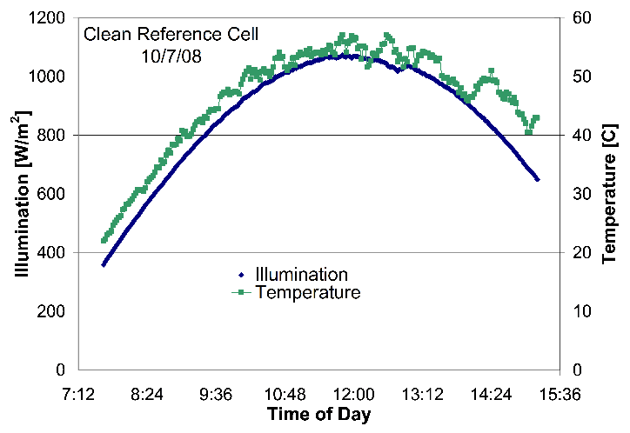

Fig. 1: Example of readable plot using different colors and line styles for clarity. (*figure caption*)

**This template contains guidance text for composing and formatting the paper. Please ensure that all template text is removed from your paper prior to submission.**